Name____________________________________________________ Period_____

**Abbreviations and equivalents.**

Recipes will often not spell out all the directions and measurements. You will need to know what each abbreviation is to have successful results.

***Common abbreviations:***

1. 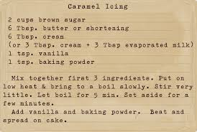 Cup-_______________________
2. Teaspoon-__________________
3. Tablespoon-_________________
4. Quart-______________________
5. Gallon-_____________________
6. Pint- _______________________
7. Ounce-_____________________
8. Pound-_____________________
9. Degree-_____________________
10. Package-____________________
11. Minute-_____________________
12. Hour-_______________________

***Equivalents in liquid measuring*.**

1. 3 tsp. =______________________________ 6. ½ pt.=_________________________
2. 2 Tbsp.=_____________________________ 7. 1 pt.=_________________________
3. 4 Tbsp.=_____________________________ 8. 2 qts.=________________________
4. 8 Tbs.=______________________________ 9. 4 qts.=________________________
5. 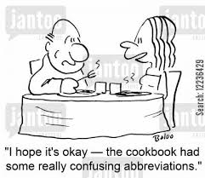12 Tbsp.=____________________________
6. 16 Tbsp.=____________________________

***To measure butter****:*

1. 4 sticks =______ pound
2. 2 sticks = ______cup
3. 1 stick=_______ cup
4. ½ stick=_______cup